

SYSTEMS DIVISION

Architecture Document

Flex GUI

Prepared by:
David Wegener
January 14, 2011

CBOE CONFIDENTIAL AND PROPRIETARY

Change History

Version | Date | Author | Description
1.0 | 1/14/11 | David Wegener | Created
1.1 | 3/30/11 | Pawan Wattamwar | Updated based in WS Security meetings. Key updates:  - Gateway to be DMZ  - IP address validation using Object Infrastructure Security Service
1.2 | 5/20/11 | Pawan Wattamwar | Updated for cometD implementation instead of webservices.

FLEX GUI Architecture Document

This document outlines the architecture for the new FLEX GUI. The basic architecture is a Java client connecting to a Web CAS. The Java Client will be a Web Start application that will be downloaded to the client PC. The Web CAS will be a CAS process with the addition of a Web (cometD) front end. It will be similar to a FIX CAS. The cometD client from GUI will open a long polling connection with cometD server. CBOE customized JSON convertor will translate cometD message into CMI structs for GUI and WEB CAS. The client and Web CAS will use cometD-Security policies to protect the privacy and integrity of the data.
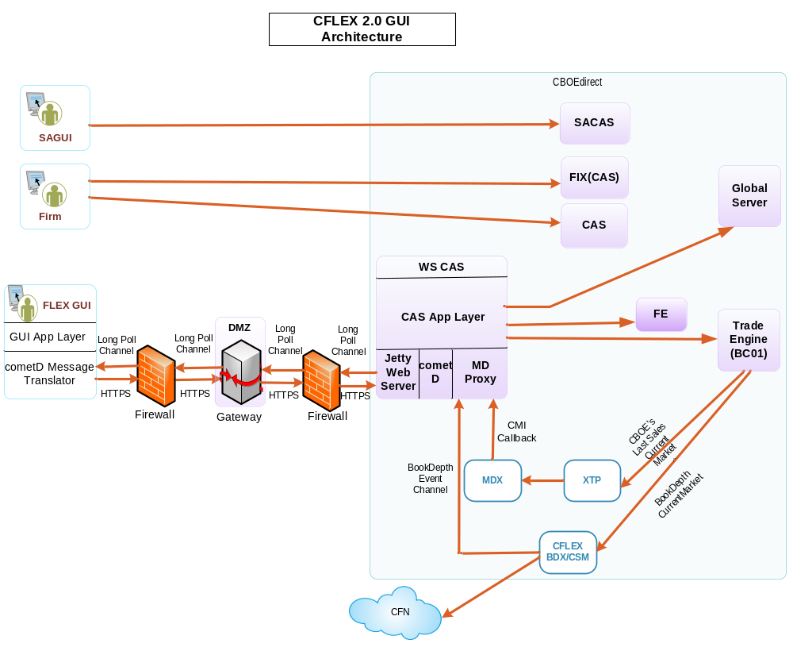

Java Client
The client will be a Web Start application. It will use code signed jar files to allow access to local resources on the host PC and to insure authenticity of the code. The client will subscribe the market data channel on the (cometD) Web CAS. The Web CAS will then publish for returning market data on cometD channels. The application needs to be able to run on Windows XP, Vista, and Windows 7. The CBOE GUI frameworks and Trader GUI components are available copied into the new code base if applicable.

Web CAS
The Web CAS used for the gui will provide client access via comteD channels (long polling framework) instead of the traditional CMI interface. This is similar to how the FIX CAS servers work. The Web interface will have cometD channel, service and dispatcher that are parallel to the CMI interface for all features needed for the client to support FLEX. The customized CBOE JSON convertor will act as an adapter to translate cometD messages to and from CMI requests. The Web CAS will need to include both a Web Server (Jetty) and a cometD server to make the interfaces available to clients.

The Web Service CAS will also need to provide a Market Data Proxy. This proxy will need to maintain current market and book depth callback instances in order to provide market data back to the client. The current market data will be coming from MDX(Market Data Server), and Book Depth information form the CFLEX BDX server. The Web CAS will need to maintain the callbacks based on subscription requests from the client. It will need to publish data on the appropriate channel to deliver it to client.

Keep alive/age sessions
The Web CAS will need to implement a mechanism to keep track of client sessions. The Web CAS will need the ability to monitor the sessions to identify when the client is no longer available. This will need to tie into the existing session management service provided by the CBOE Infrastructure. It will also need to interface with the Market Data Proxy to make sure that data subscriptions remain in sync with active clients.

Secure communications/Authentication
In order to protect the parties involved, communications between the client and the Web CAS will need to be secured. Security will require both encryption to prevent eavesdropping as well as signing to prevent message tampering. Both the client and the Web CAS should utilize HTTPS and cometD-Security policies to secure the communications.

A procedure will need to be developed to insure that the proper security keys are generated and registered.
IP based validation and user authentication will be required using CBOEdirect Security services. The authentication would be done by Object Infrastructure Security Service running on gc2a. The authentication would be done two steps:
- User Authentication
- For user id marked as restricted, the IP address would be checked. There are 3 types of IP address validation supported:
  - Single IP Address
  - Subnet
  - IP Address Range
Table, SECURITYUSER, in infra GCD would be used for IP address validation

